BUREAU OF INDIAN STANDARDS
(SELF EVALUATION-CUM-VERIFICATION REPORT)

- GENERAL INFORMATION
  - Applicant’s Name –
  - Enclose Plant Layout: Enclosed

- RAW MATERIALS
  - Raw Materials Used: Enclosed

- PACKING AND MARKING

- Nature of packing – Cartoon Box
- Quantity per package – 01 Pcs
- Marking on article – As per IS except ISI mark
- Method of marking (printing, Stenciling, embossing etc.) – Embossed PVC Tag/Label
- Form of label(s), if any (enclose one set) – NA
- Batch or Code numbering for identification - Batch Number
- In what manner marking differs from the provisions in the Indian Standard Specification – As Per ISI

- Details of Quality Control Staff:

Sl. No. | Name of | Designation | Qualification | Experience
Sl. No. | Person | Designation | Qualification | Experience
1 | Sunil Kumar | Quality Control | B.Ed. | 1 Year

- Brand Name(s) - AQUA PEARL

DECLARATION OF BRAND NAME/
TRADE MARK PROPOSED TO BE COVERED UNDER CERTIFICATION
  - Brand Names/Trademark(s) being used:

Brand Names/Trademark(s) | Owned by | Registered/Unregistered | Date of
which would be marked on the | self or | Registered/Unregistered | Registration/
product bearing the BIS | others | Registered/Unregistered | Introduction
Standard Mark (Give actual |  | Registered/Unregistered
design depiction of the Brand |  | Registered/Unregistered
Name/Trade Mark(s) |  | Registered/Unregistered
LITTLE NAP | Self | Registered | 04-04-2018

- Other Brand Names/Trademark(s) used for the same product marketed without BIS Standard Mark. Give reasons. - NA
- In case Brand Names/Trademark(s) of any other party/manufacturer is being used for purposes of the above, give the design depiction of the Brand Names/Trademark(s) and copy of the agreement authorizing the use of the same. - NA
- I/We undertake to inform BIS in advance as and when we propose to use any other Brand Names/ Trademark(s) in conjunction with the operation of the BIS Certification Scheme.
- I/We also undertake that, as far as possible, the entire production which conforms to the specification shall be marked with the BIS Mark, irrespective of the Brand Names/Trademark(s) used.
- I/We understand that the above has been given only as information to BIS, that BIS has no role in permitting/approving of any Brand Name or Trade Mark, that this is not in anyway be interpreted to mean that BIS has permitted/approved the use of the Brand Names and Trade Marks listed above, and that the responsibility is entirely mine/ours.
- I/We understand that for the previously held license which was cancelled/expired/ surrendered due to failure of samples (including the cases of expiry/surrender, where cancellation due to failure of samples was contemplated), the certification application will be processed only under option-1 (normal) procedure

DECLARATION
The information given in this report are true to the best of my knowledge and belief. I shall be responsible if any misleading information has been given in this report and the application shall be liable for rejection if wrong information has been given. If the license is granted on the basis of information which is found to be incorrect later, the license shall be liable for cancellation.

Date: 21/07/2025
Place: Plot No. 140, Sector 4, IMT Manesar, Gurugram, Haryana 122051 | 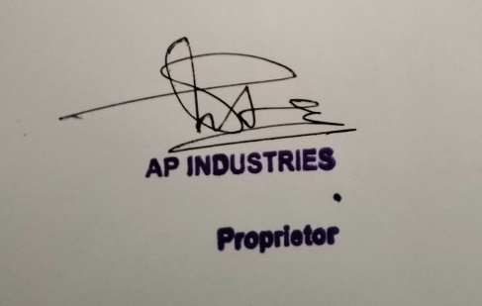  Name: Yogendra Singh Yadav  Designation: HR & Admin

